
WEDDING RECEPTION DETAILS
PLEASE FILL OUT COMPLETELY AND RETURN NO LATER THAT 30 DAYS PRIOR TO EVENT DATE EITHER IN PERSON AT A SCHDUELED CONSULTATION OR BY USPS MAIL

To help us be fully prepared, the following information will ensure that no details are overlooked for your special day, please make sure to add additional information as needed.

- What time does your venue location open:

- Approximately what time do you anticipate guests arriving and dinner starting:

Grand March Details

Do you want any type of grand introduction?
If yes, fill out below.

*your grand march can include anybody that you like.

Ushers: _____________________________________________________________

Parents of Bride: ______________________________________________________

Parents of Groom:______________________________________________________

Flower girl & or ring bearer:_______________________________________________

Groomsmen Bridesmaids

_______________________ ___________________________

_______________________ ___________________________

_______________________ ___________________________

_______________________ ___________________________

Groomsmen Bridesmaids

______________________ ____________________________

______________________ ____________________________

______________________ ____________________________

Best Man Maid /matron of honor

______________________ ____________________________

Bride and groom (how would you like to be introduced?

Grand March song selection:
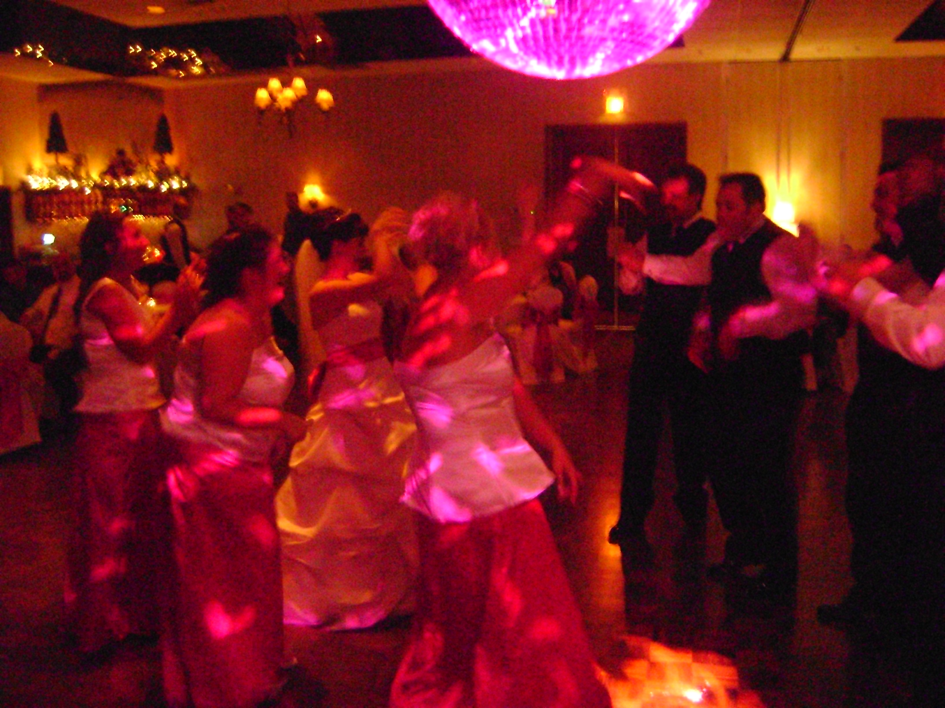

Introduction song:

1st dance:

Bridal party:

Father daughter dance:

Mother son dance:



Additional grand march novelties:

Garter take off and toss song(s):
-please note if take off should be conservative-

Bouquet toss song:

Dollar dance:

Anniversary dance:

Fathers and daughters:

Help us get to know you

- When & where did you meet ?

- Who asked who out? Did they say yes the first time?

- Where did the bride go to high school, what year did she graduate?

- Where did the groom go to high school, what year did he graduate?

- College (years attended and place)?

- Do either have a nickname in family circles or with close friends?

- How long together before getting engaged?

- How did the proposal happen?

- How long have you been engaged?

Are you going on a honeymoon? If yes, where?

- What are you most looking forward to in years to come together as husband and wife?


If you love the chicken dance...so do we!
You Envision, we listen, we all party!

General wedding reception novelties (please X off is not desired)

Chicken dance Hokey Pokey Polka

YMCA Electric Slide Macarena

Cupid Shuffle Superman Cha Cha slide

Please note any songs, artists or titles you DO NOT want played:

Is there any special announcements, dedications or speeches you would like to make?:

Are there any special family circumstances or arrangements we should be aware of?
(ex, divorce, blended families, family members no longer with us?)

Any other details your dj should know?

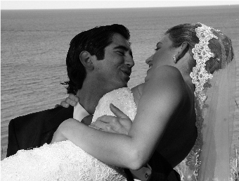
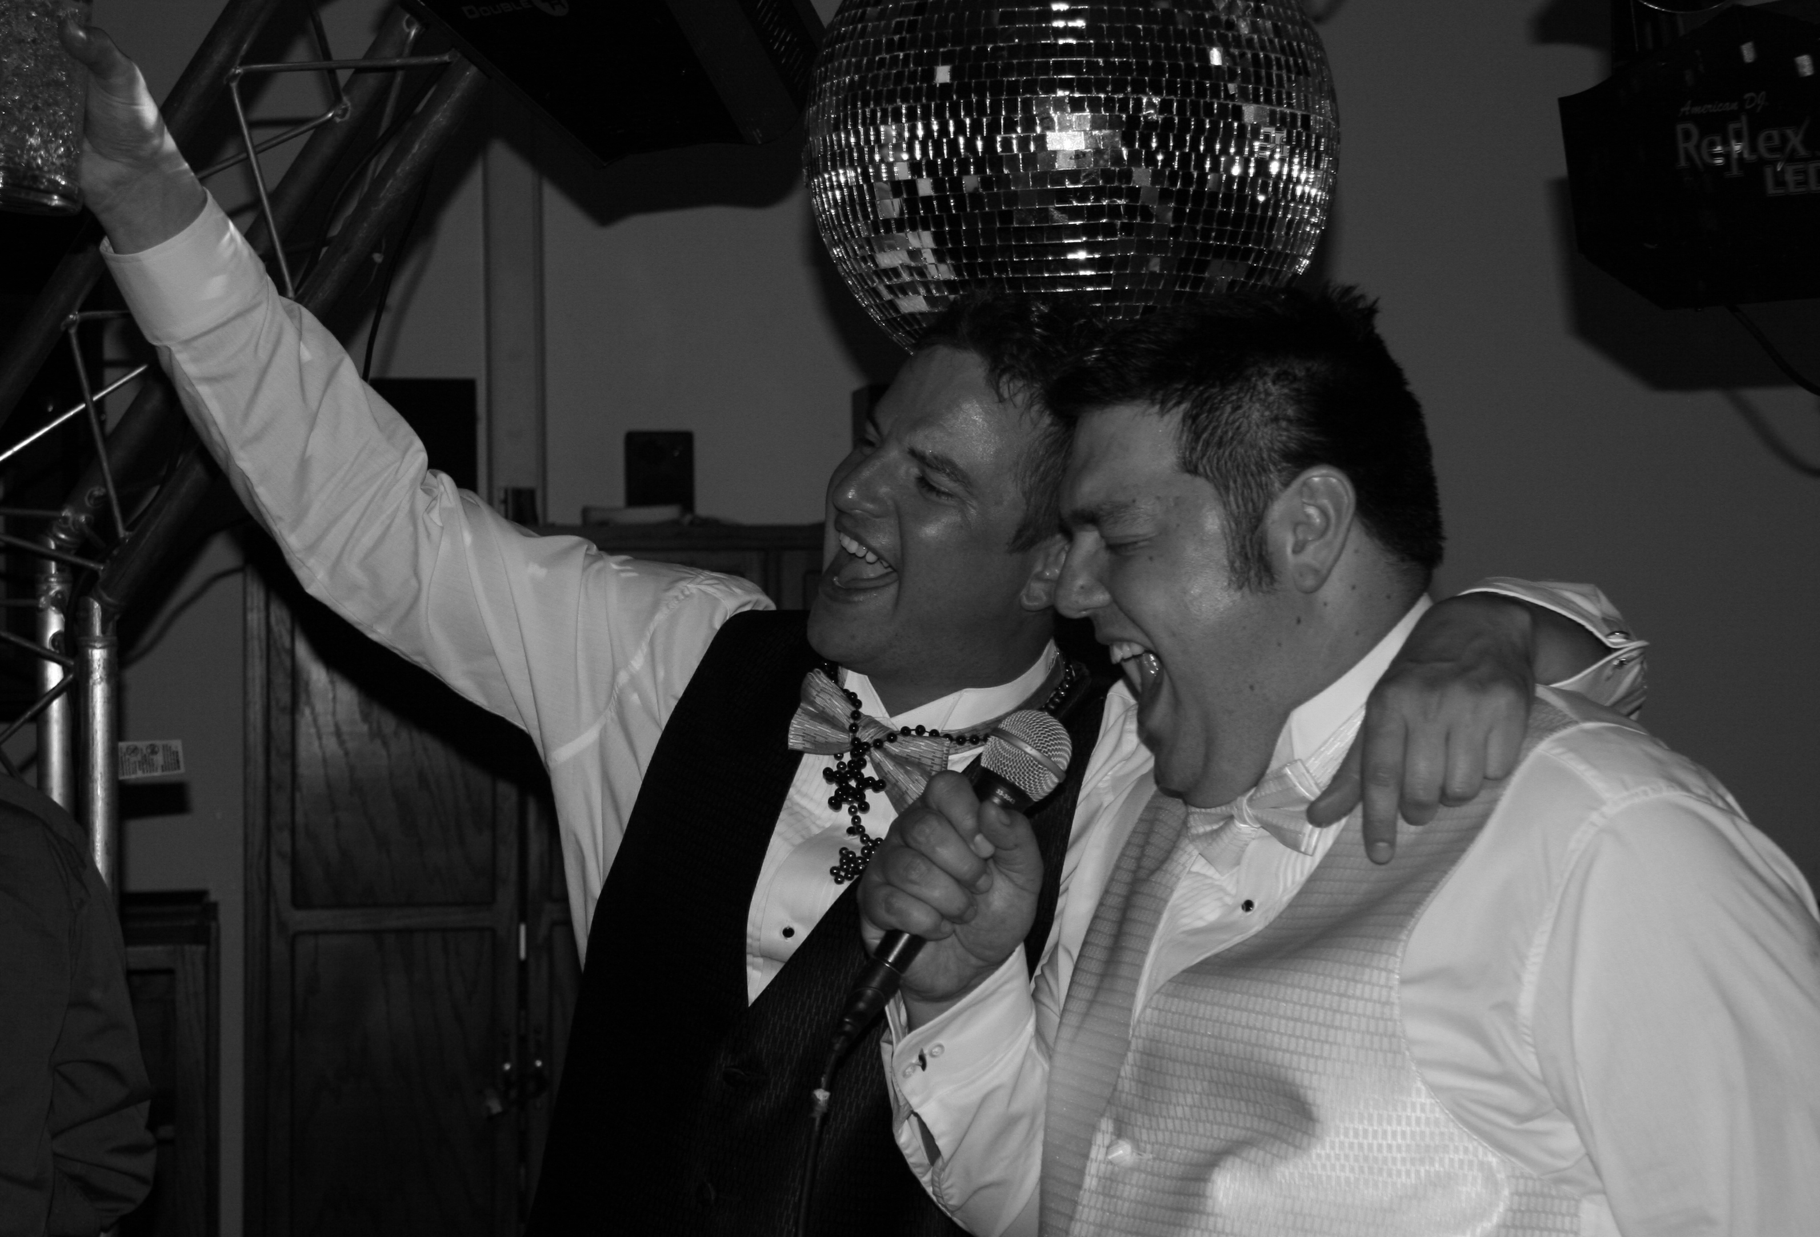
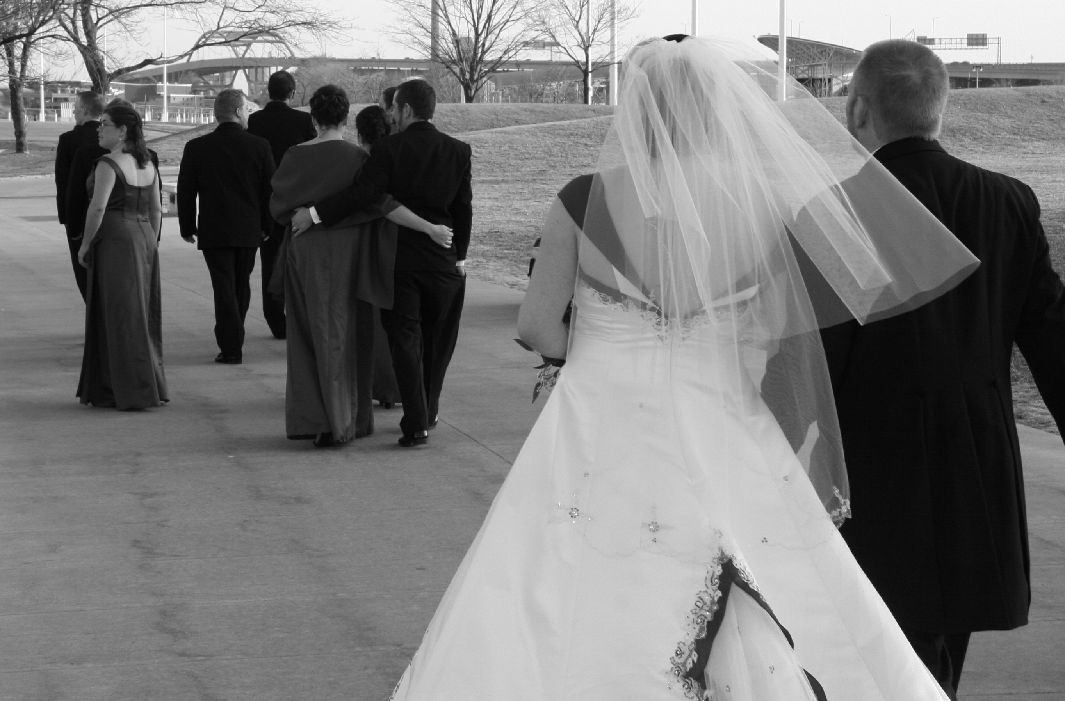
It's all about making memories here!

LIST AT LEAST 10 OF YOUR FAVORITE'S!
Any additional requests, list both song and artist

Song / Artist Song/ Artist

